Subscription services are a fast-growing area of the marked. In the las 5 years the market has grown by over 100% based on the revenue from subscription e-commerce companies on the internet retails top 500 list (1). Not just common media subscription services such as Netflix or Disney+ these have branched out into others areas such as cosmetics, games, and foods. As such many people now have one if not multiple subscription services being paid directly from their accounts each month. Although this does lend itself to ease of payment it also allows for the consumer to lose track of payments or services they no longer use. C+R Research did a survey to find out information about this subject in 2022 (2). In this survey they found that on average consumers underestimated how much they were spending by 2.5 times. This shows how easy it is to lose track of your spending when using these services that are becoming for more common. Not only the spending, 42% of people had services that they forgot they were even subscribed too. Chase did a similar survey in 2021 and found that 60% of its users had forgotten about at least one subscription service (3). The most common of these are media services which were shown that 46% of online shoppers use one of these with 15% using other services (1).

Due to the rise in subscription services, there has also been the creation of websites and apps to allow consumers to track and manage these subscriptions. There are many types and some have specific uses but there are some very popular ones that are commonly used. First is an app called Rocket or rocket money. This app is more than just a subscription tracking app as it also allows budget management for your accounts and can take other payments into account. It also allows for bill negotiations, spending insights and credit score. One important feature of this app that makes it so popular is that you can connect you back account to it and it will automatically find your current subscriptions from your payments. They also provide a service to cancel your subscriptions for you at your request.

Trim is another service for managing subscriptions. It mainly works on their website though it can be accessed from a mobile device as well. Much like rocket this site can link your bank account and find your active subscriptions. It also has the request to cancel option present. Trim also offers services like bill negotiations and giving advice from spending for ways to save money.

TrackMySubs is another website-based service for managing subscriptions and recuring payments. Originally designed for small businesses it branched out to consumers as well. This site does not link any bank accounts and some consumers may rather that as they are not comfortable connecting their accounts to 3rd party software. This site allows the customer to manually add subscriptions and services to the site as well as set up alarms for next payments and how much has been spent so far.

These three apps / sites are a good example of current software that is available for managing your subscriptions and recurring payments.

A survey of how people logged into sites and services was done by Statista in 2016 (4). This found that the two most common logins by a large margin was Facebook and google. The roughly represent 20% of total logins accounting to Addshoppers.com across their network of online shoppers (5). Also mentioned is the reasons customers gave why they would rather sign up using social logins. 65% say it’s faster than registering on a website (time is money). 50% said it means one less password to remember and 12% say it ensures the website is personalized. This was in 2016 and has been on the rise since.

Overall, it seems that this is a very valid and rising area for a website or app to be created. Many people prefer to log in with social logins like Facebook or google so this could be integrated into the app. Further research into the banking connection for auto adding apps may be needed if it is within the scope of a final year project. Have not investigated moving it to a cloud service as of yet, will confirm viability first. Seems app vs website are about half and half so either should work and most sites are mobile friendly. The most common functions are tracking, alarms and cancelation which would be best to have along with auto adding subscriptions for those that connect a bank account.

TrackMySubs is a website-based service for managing subscriptions and recuring payments. Originally designed for small businesses it branched out to consumers as well. This site does not link any bank accounts and some consumers may rather that as they are not comfortable connecting their accounts to 3rd party software. This site allows the customer to manually add subscriptions and services to the site as well as set up alarms for next payments and how much has been spent so far. These are the steps for signing up and add subscriptions to this service. (6)

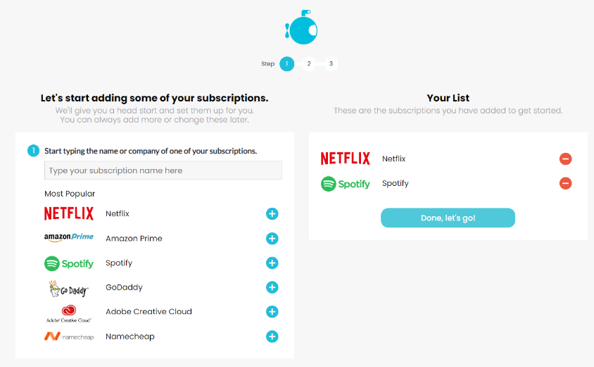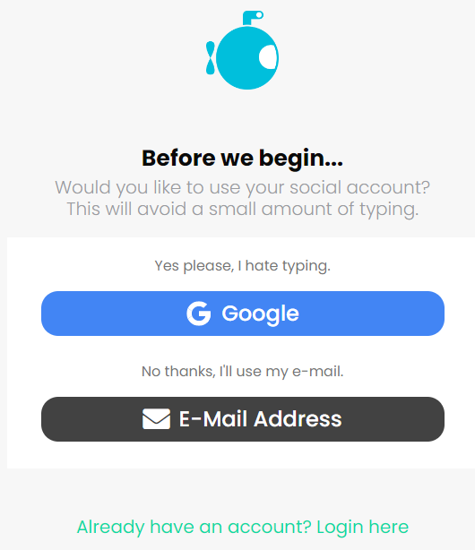When first signing up there is the option of using google to auto sign in or creating your own account manually with an email (fig 1). Both of these steps will eb shown but the end result is the same. Should you choose to manually create your account you will initially be prompted to add some of the more popular subscriptions or search for less popular ones by name (fig 2).

Figure 2

Figure 1

After this is done you will then be prompted to enter and confirm you email address (fig 3).

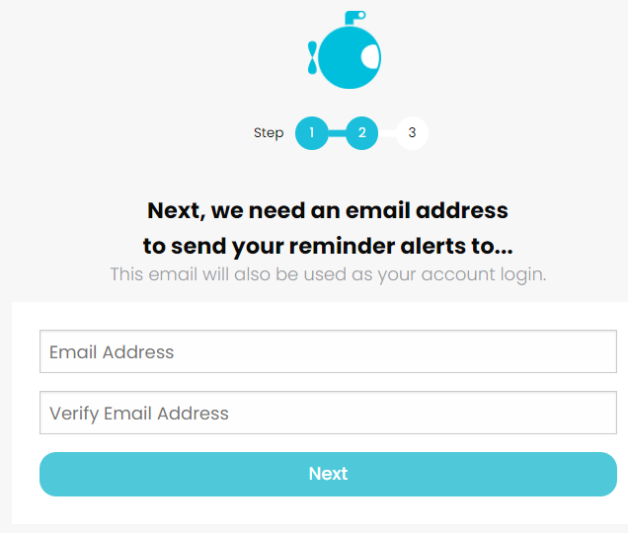

Figure 3

The final stage of manual setup is entering you name, password, agreeing to the terms and conditions and completing a captcha (fig 4).

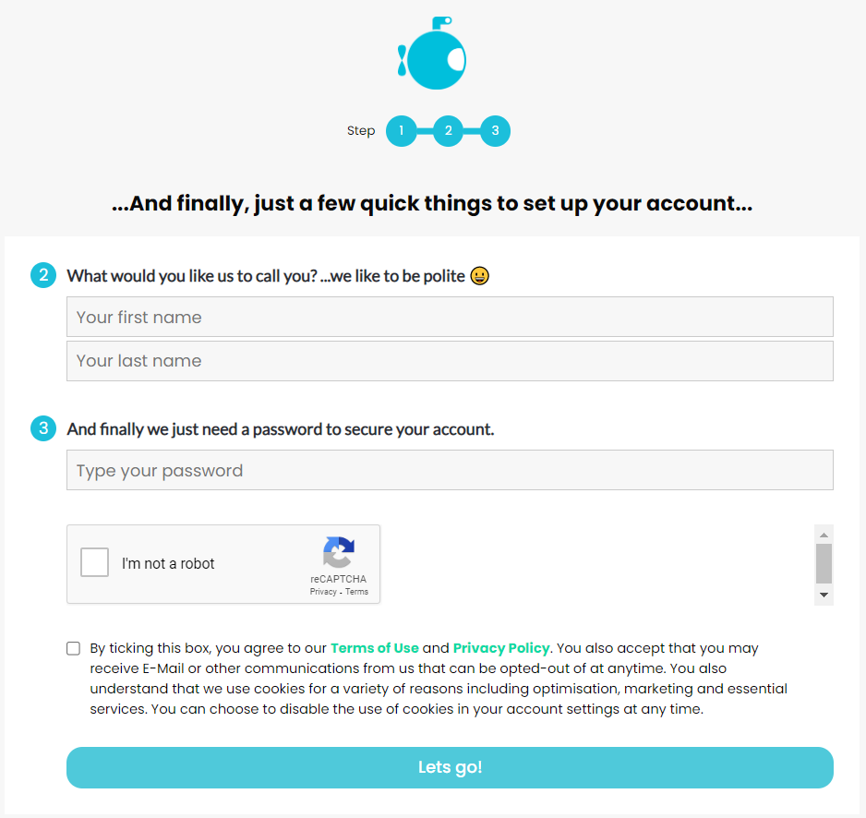

Figure 4

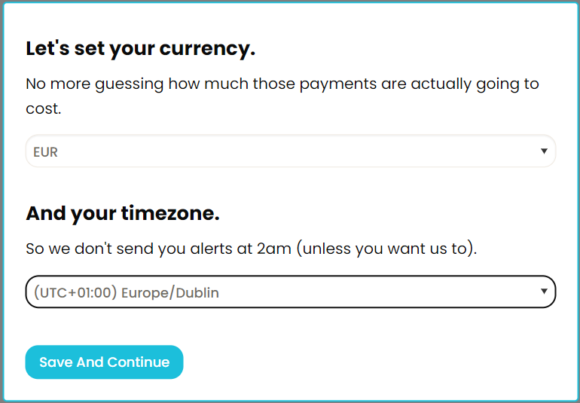Once your account has been created you will be asked to select your currency and your time zone to make sure alarms ring at the correct time and your costs are correct (fig 5). You will also have been sent a verification email.

Figure 5

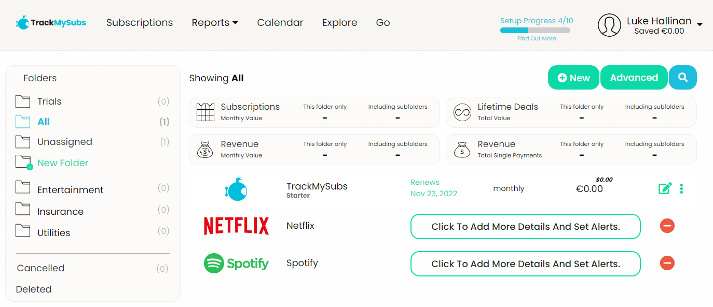Once all this has been done you will be brought to the main homepage shown below (fig 6).

Figure 6

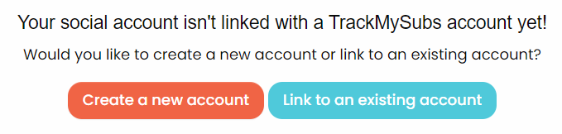Next will be a run through of using google to sign in. upon clicking google in fig 1 you will be prompted to select your google account and be brought to the below page (fig 7) to either create a new account or link it to an existing trackmysubs account.

Figure 7

If you create a new account from here the menus in figure 3 and 4 are auto filled for you. After clicking through the same as a manual account you will be brought to the same homepage in figure 6. This page holds most of the functionality for the site. The folders on the left are for the user to split up their subscriptions as the desire and get the total value of subscriptions in each. These can be customized to be anything grouping the user wishes.

The four main types of tracking are shown above the current folders subscriptions. These are the subscriptions section, lifetime deals and revenue for monthly and single payments. These each display they total values of all recurring payments in the folder and sub folders. The “All” folder can be used to get the total of the whole account.

New subscriptions can also be added here using the new or advanced buttons. The new button is the simpler way to add as it breaks up the process and allows some to be filled automatically. This process is shown in figure 8 – 16 below in order. Each of the options in figure 8 set the text box type in figure 9 but all the other windows stay the same. As you type the company section autofills suggestions and as in fig 10 and if it is a know one then the icon or name will appear as the image like figure 11. As shown in figure 13 there is a calendar dropdown to select the date of the payment and it will show this as in figure 14. Finally after entering the cost, you will be able to set an alarm to notify you when the payment will recure. The default setting for this is an email to the address that was used to set up the account but other emails can be added is the user desires.

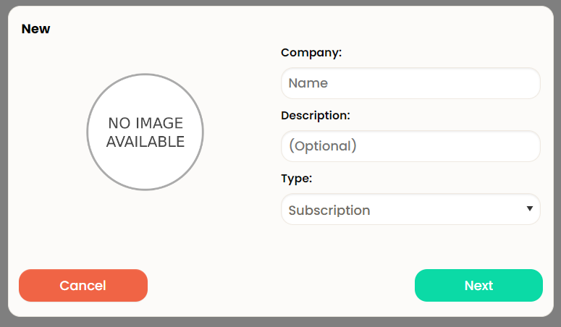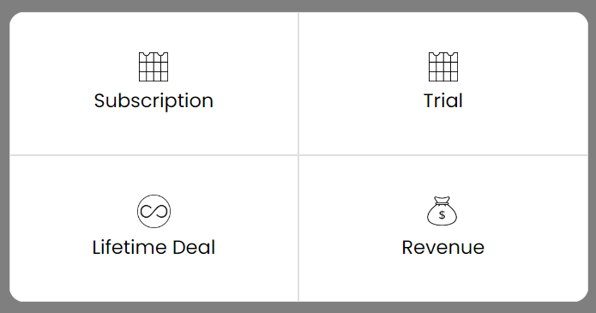

Figure 9

Figure 8

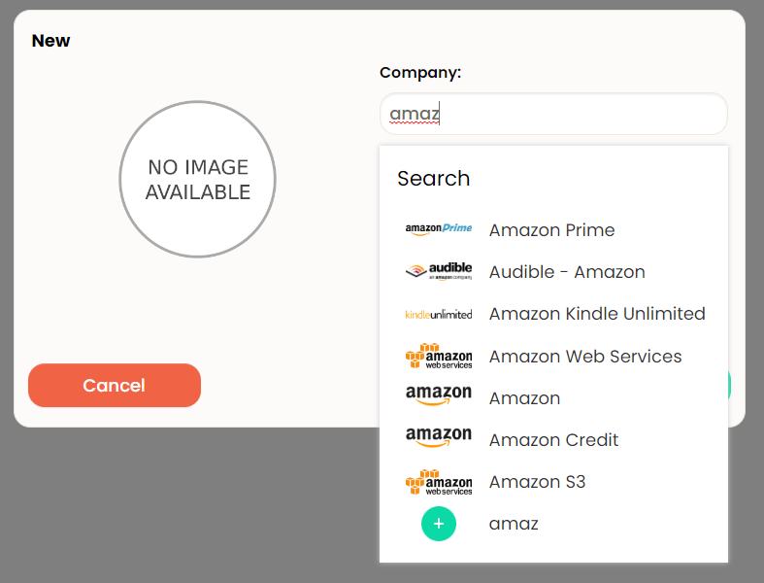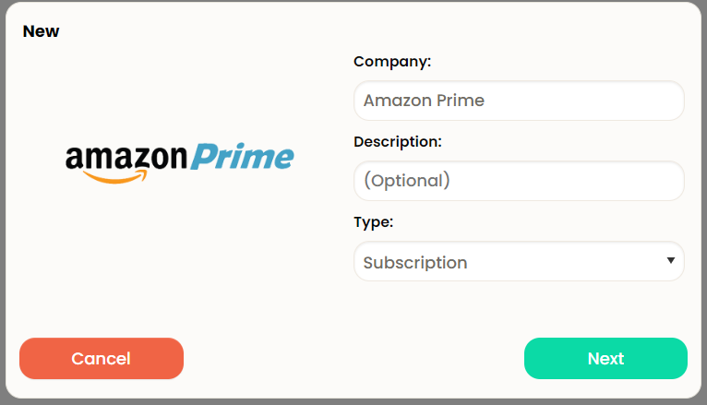

Figure 11

Figure 0

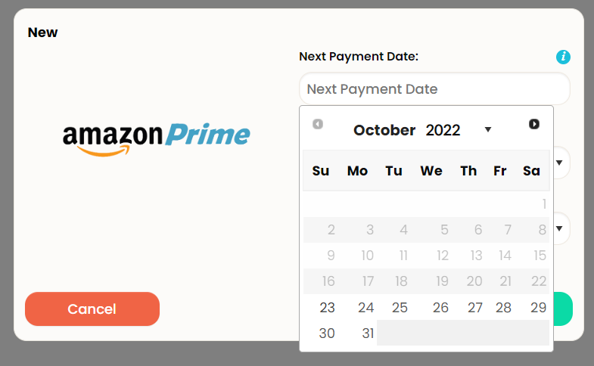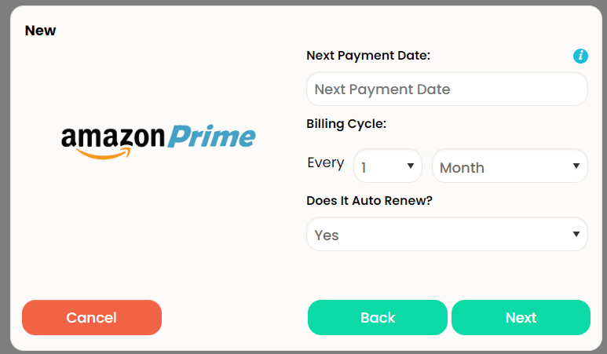

Figure 12

Figure 13

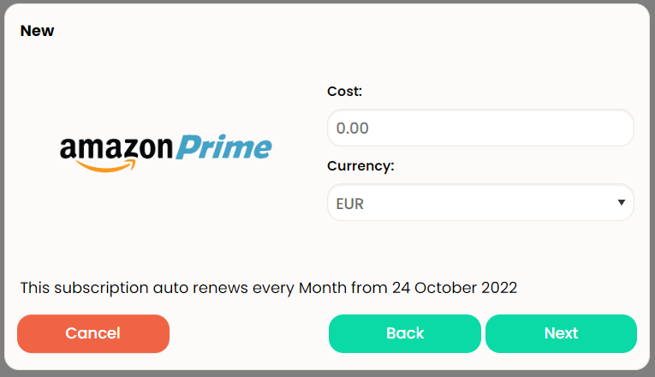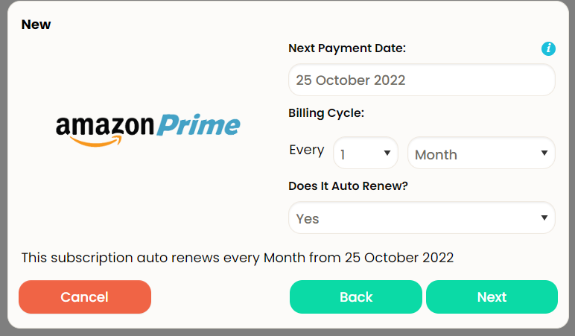

Figure 14

Figure 15

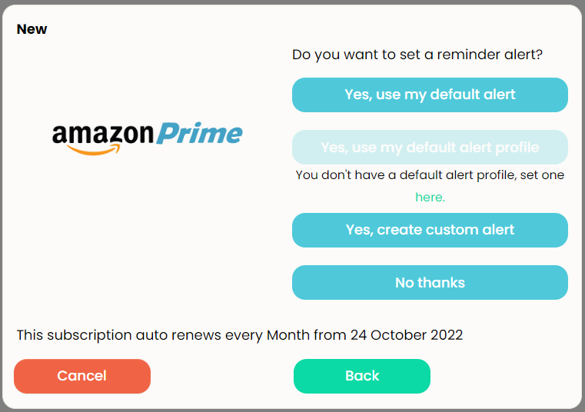

Figure 16

The other option for adding subscriptions is the advanced button which gives all the details In one large window shown in figure 17 below. This also has some additional sections such as contract expiry and url link to the website of the company. You can also specify the folder and add tag for the sake or organization. Contact manager allows you to add contacts for the alerts to use and the alert manager uses these to let the user know when a payment is due.

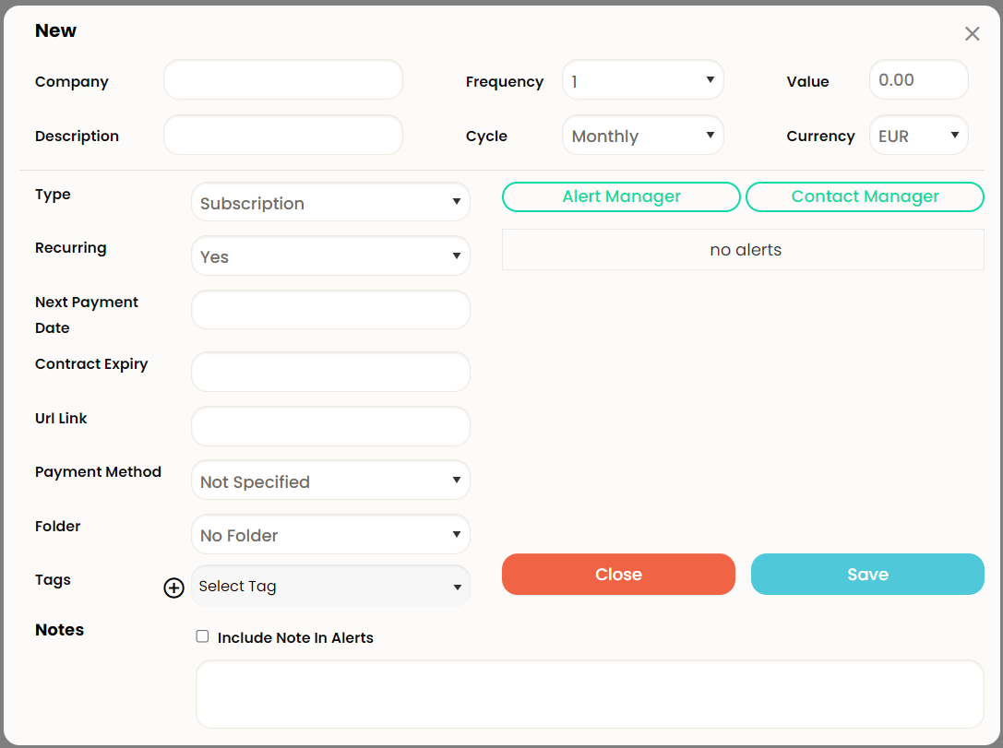

Figure 17

When adding an alarm for a payment you get the popup shown below in figure 18. Custom alerts is the alarm id. When selecting when to be alerted you have a choice of a day, week, or month before as shown. The reason for the alert can be for a payment o/ trial expiry date or the contract end date. Finally, the contact is selected from the ones you add in the contact manager and by default only has the name and email used to set up the account.

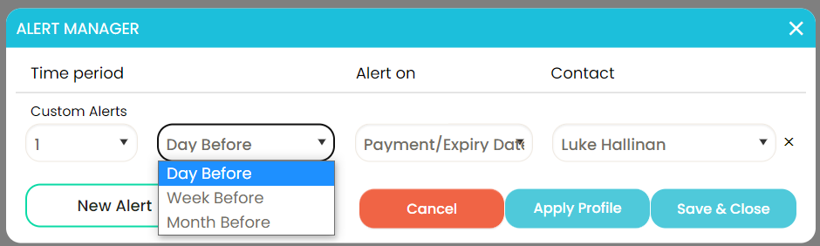

Figure 18

Once all this has been done the subscriptions will be added to the homepage. While there on the right of each subscription is an edit button and three dots that show other options for that sub as shown in figure 19 below. From left to right these are delete, pause, duplicate, attachments, edit history, payment history, alert manager and finally a button to close the options menu.

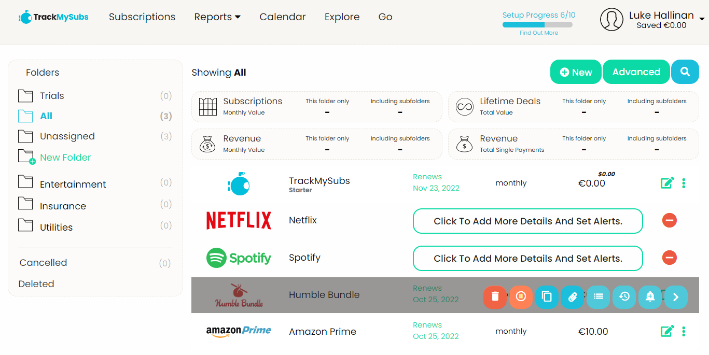

Figure 19

This website also has features in the top banner for reports, calendar and popular subscriptions called explore. Each of these will be shown below. First is the reports section (fig 20).

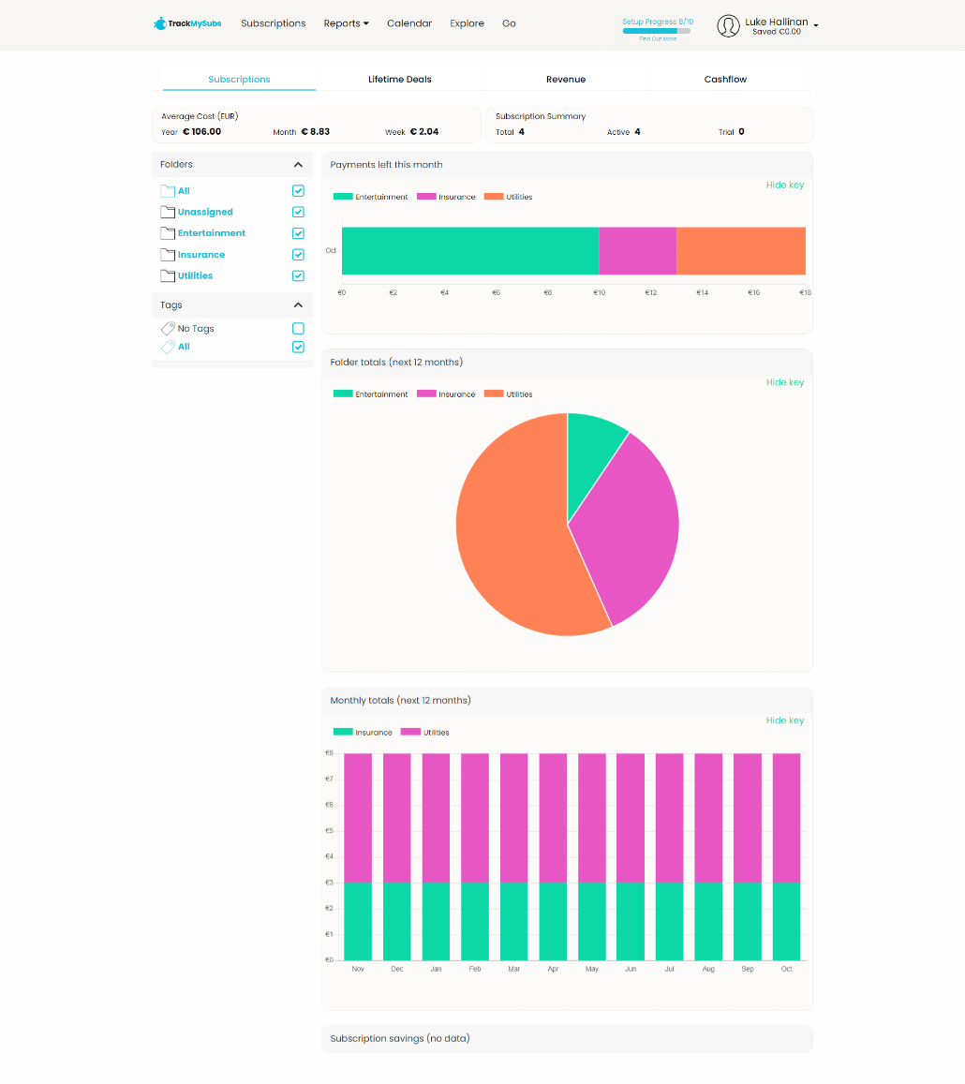

Figure 0

This page allows the user to view their monthly and yearly totals and other information about each folder of payments. This is all generated automatically for the user from their input data. It can also be filtered based on folder, tag and payment type if needed.

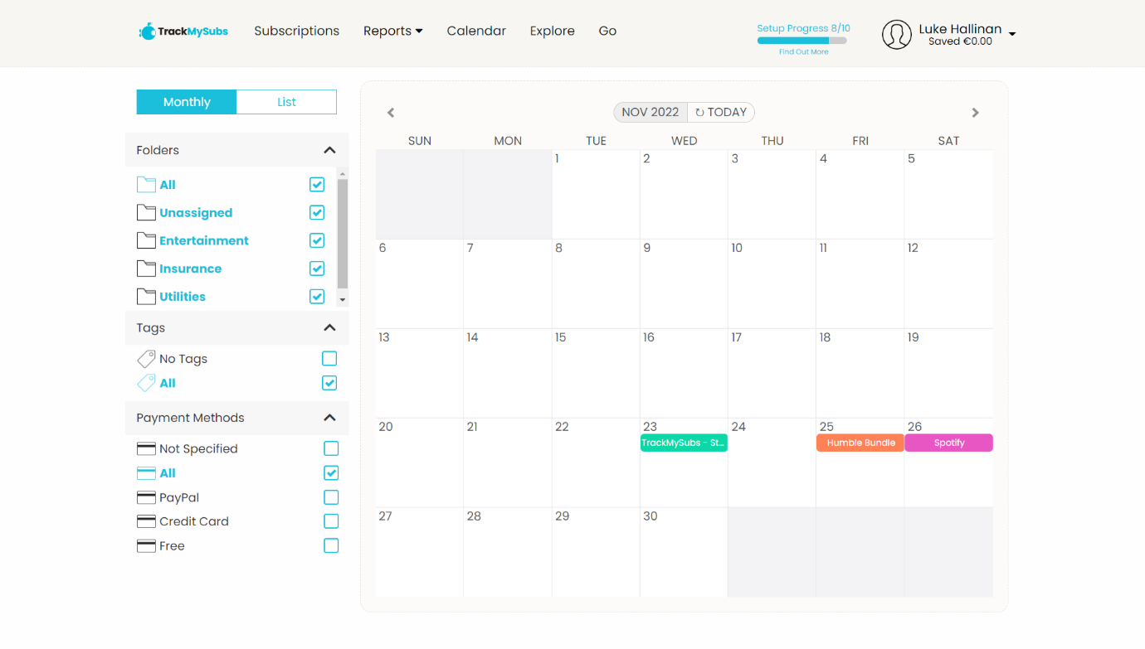Secondly there is the calendar page shown in figure 21 below. This can be used to look ahead and get a good idea of what is due when. Like the reports it can be filtered the same way and auto colours each folder.

Figure 21

Finally, is the explore section that allows the user to look at popular subscriptions and lifetime deals shown in figure 22. Any of these can be selected to give information about them such as their price, rating, and cancelation rates (fig 23).

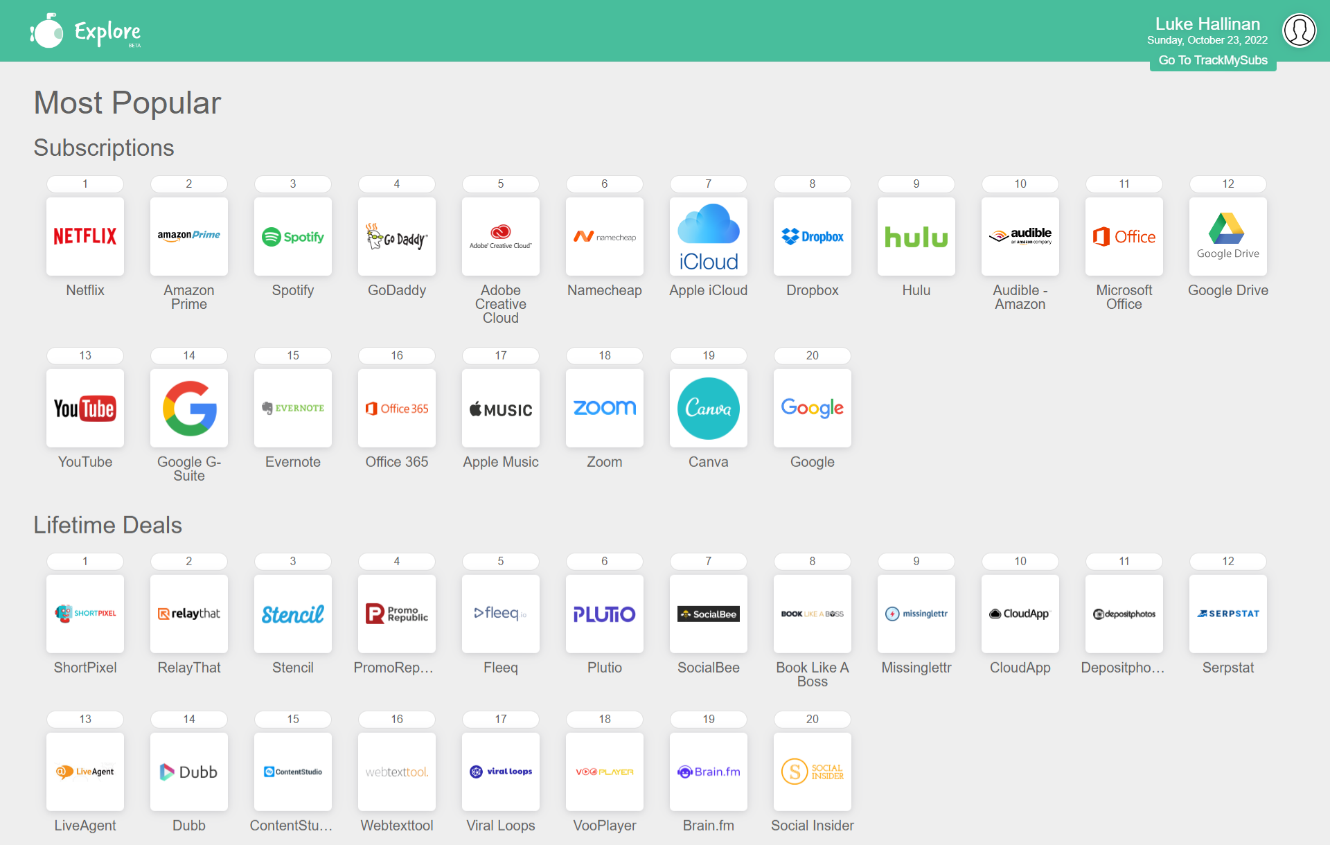

Figure 22

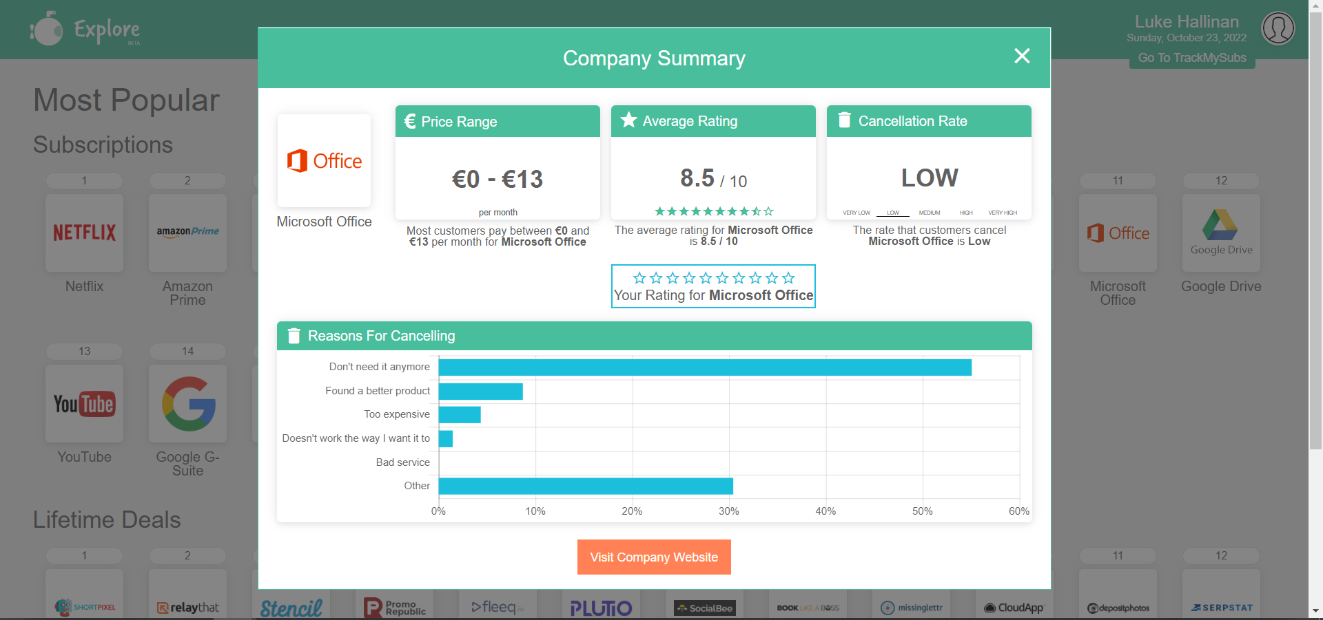

Figure 23

This site is very similar to this project and as such has been researched in more details. Features such as adding subscriptions and alarms will work much the same way with some minor differences. Although the file system is a good way to organize your subscriptions it takes up a lot of space even if it is unused as shown above. None of the subscriptions are added to any folders yet the entertainment, insurance and utilities folders are still visible and can be selected. Likewise, the options for single payments and lifetime deals are unnecessary as they are no currently in sure and due to the nature of these item there would be no recuring fees.

The data is not stored on the local machine as such it must be requested from a database elsewhere when loading the page. This is the most common method for this type of site and will more than likely be the same method used in this project.

Trim works predominantly as a text service. Trim required a phone number to sign up. You can also add an email if you wish and get email notifications much like trackmysubs and rocket money. It also requires you to add your bank account to make an account and auto add subscriptions.if any subscriptions are missed they can be added from the transactions menu

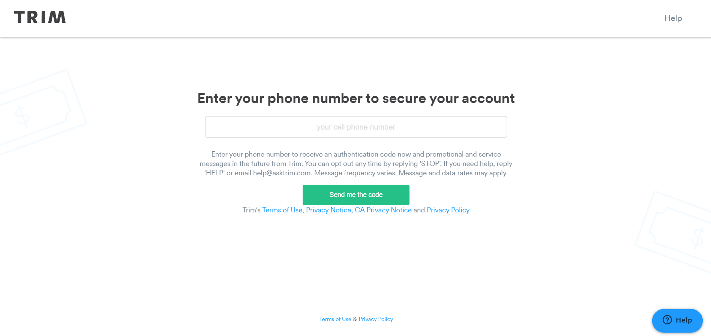

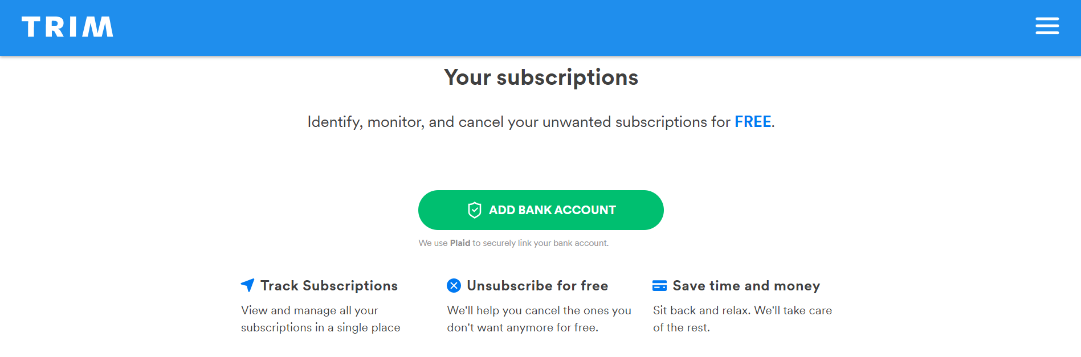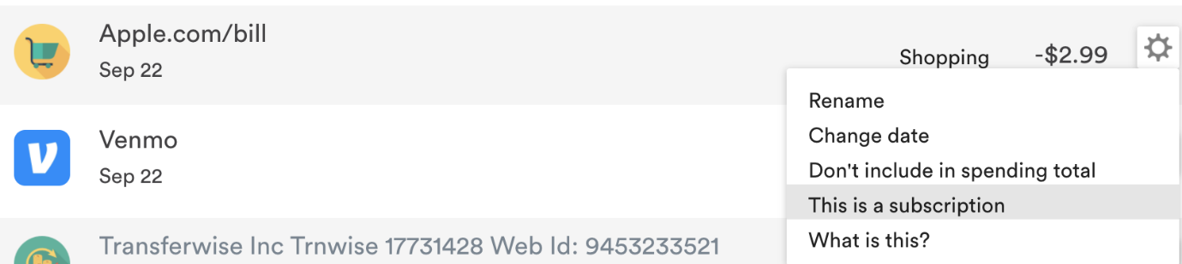

Rocket money on the other hand needs an email and a bank account or credit card to start up an account. This allows it to auto add all your subscriptions and payments and well as assist you in saving m0ney elsewhere.

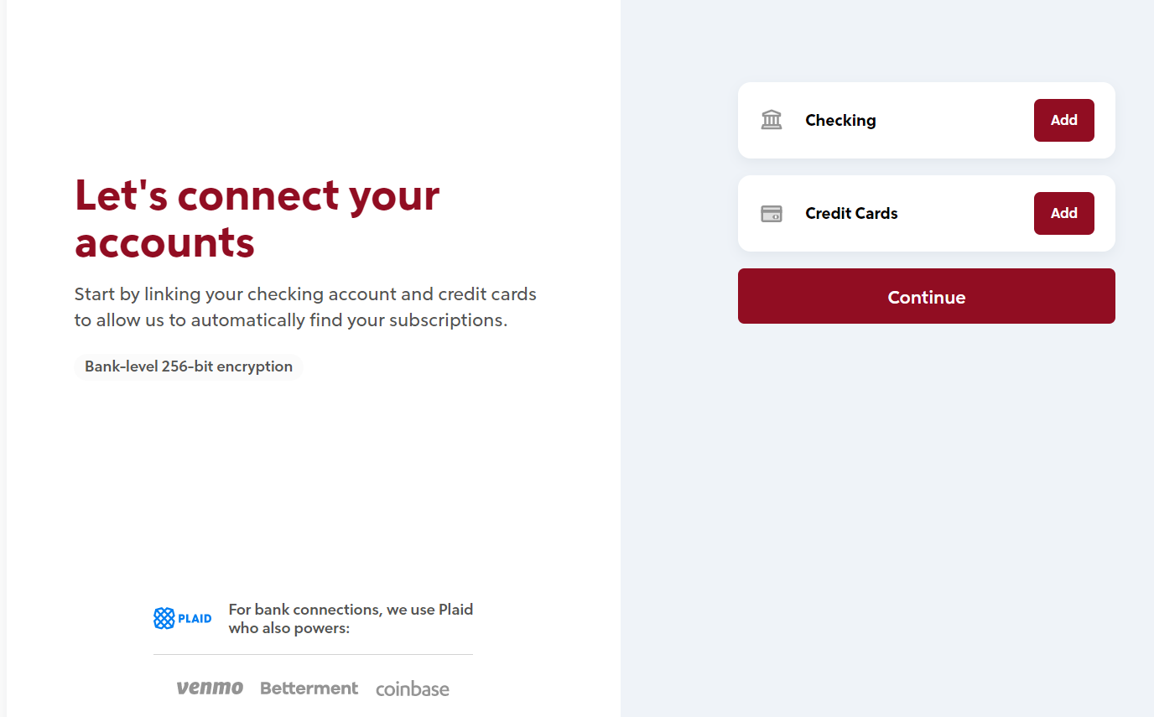

Rocket money allows you to track you balance in accounts that are connected as well as the options to give advice on smart saving such as cancelling old unused subscriptions and investments of savings

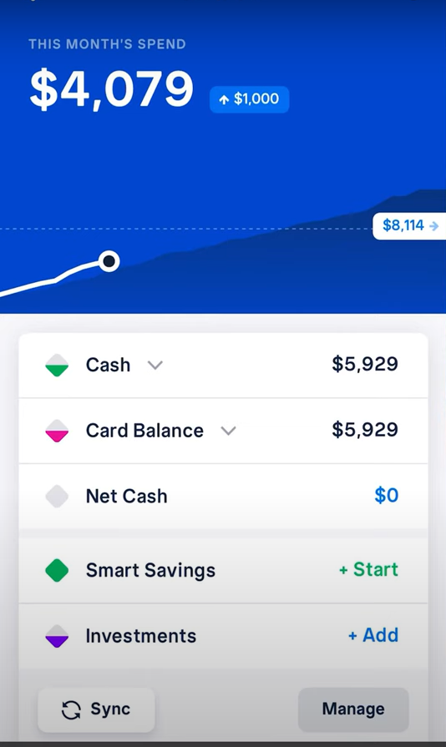

Much like track my subs rocket money has similar features for tracking monthly spending. They also have extra features such as credit score as you have linked your bank account. Aslo much like trackmysubs there is a calendar of upcoming payments to allow you tog et an overview of that months spending.

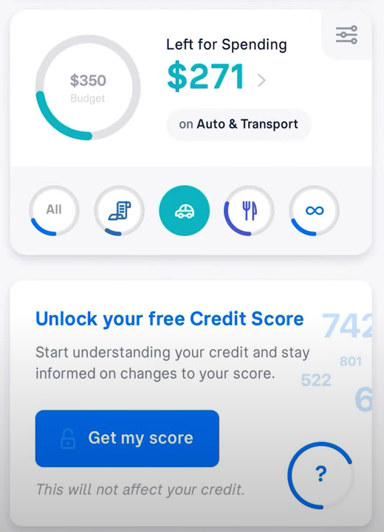 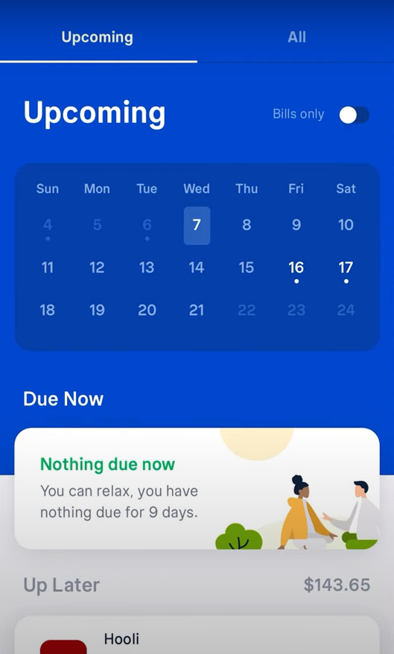

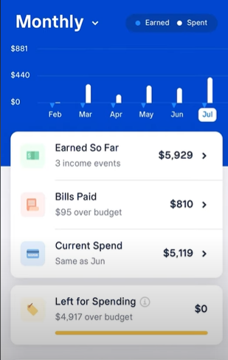

Rocket money also has a subscription tracking page like the homepage of trackmysubs. These subs are automatically found when you connect an account. For rocket money this also includes payments suck as utilities and bills much. These sorts of payments can be added into trackmysub and manually sorted as utilities too. Should rocket money fail to find a sub you have the option to manually add it in. these subscriptions can also be clicked to go into more details for each one and add notes to them.

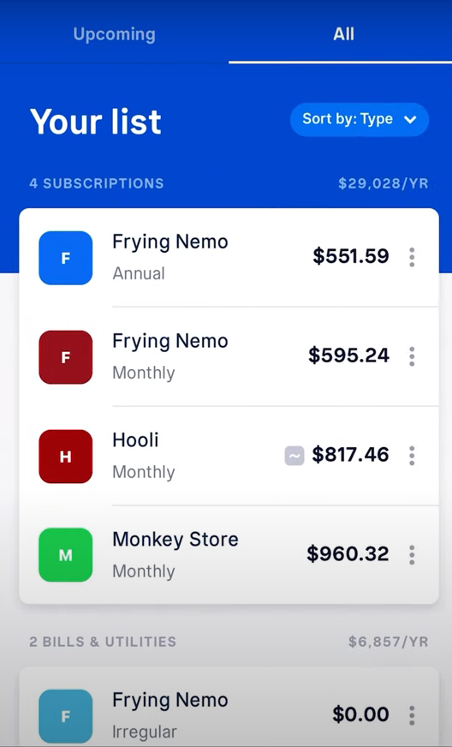 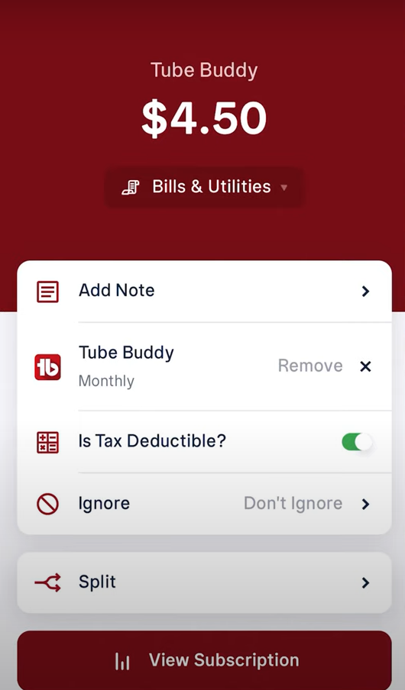

Rocket money can also be access online. The homepage has your subscriptions and bills much like track my subs does. This will give you a list of current s subscriptions and bills as well as the amount spent last month. It also has the option to manually add in any missing subscriptions. Each sub also has the next payment date and its frequency being weekly/ monthly/ yearly.

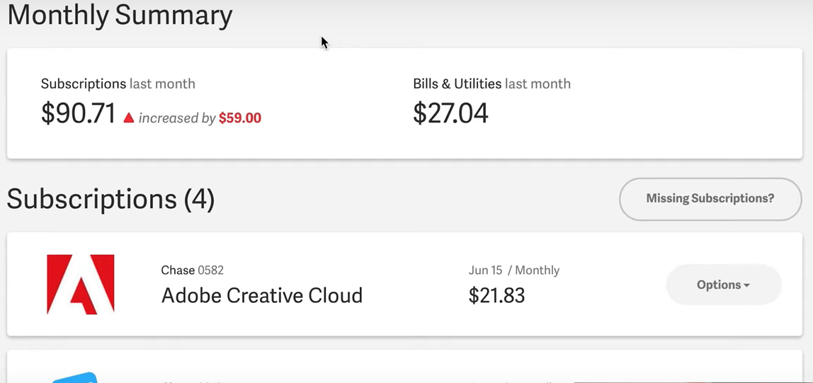

Rocket money also allows you to cancel subscriptions but unlike trackmysubs there are multiple ways to do this. For subscriptions that allow it you can cancel my email to make it easier and quicker for you. Not all subs allow this option so the other two are more common. Rocket money can try to cancel your subscription for you through the app’s website. Some apps do not allow cancellation on your behalf or you might be reluctant to give the subscription account username and password so you will need to do it manually. In this case rocket money will give you step my step instructions on how to cancel each service. This is very useful as some companies make cancelation complicated or convoluted. In the case of some popular sites such as Netflix they even have video tutorials on how to manually cancel.

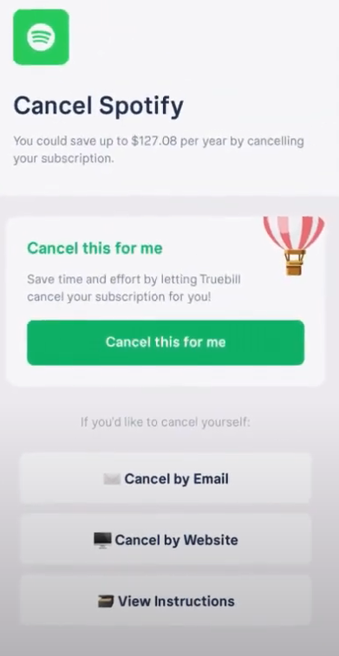 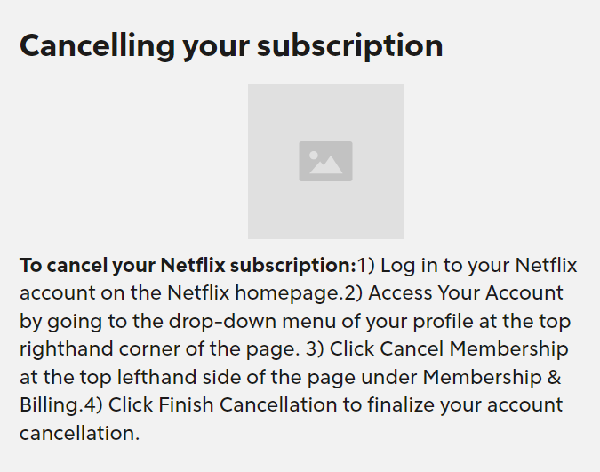

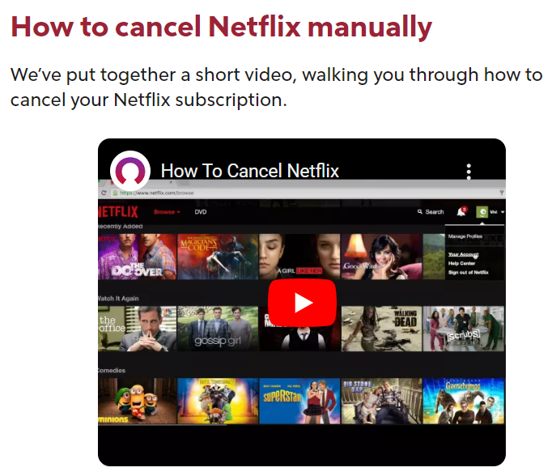

Common Features:

* Current subscriptions / bills page
* Monthly spending / budgeting page
* Calander of upcoming payments
* Cancel subscriptions
* Alerts for next payments (email / text)
* Google / Facebook login
* Manually added subscriptions
* Payment type organizations

Useful features:

* Ignore subscription options
* Linking bank accounts
* Subscription cancelation instructions
* Payments list tab

Other notable features:

* Bill negotiation

Survey: <https://forms.gle/ycKB1KRyKj9wE8TY8>

1.

Trends and opportunities in the subscription e-commerce market | McKinsey [Internet]. [cited 2022 Oct 16]. Available from: <https://www.mckinsey.com/industries/technology-media-and-telecommunications/our-insights/thinking-inside-the-subscription-box-new-research-on-ecommerce-consumers>

2.

Subscription Service Statistics and Costs – C+R Research [Internet]. [cited 2022 Oct 16]. Available from: <https://www.crresearch.com/blog/subscription-service-statistics-and-costs>

3.

Survey from Chase Reveals That Two-Thirds of Consumers Have Forgotten About At Least One Recurring Payment In The Last Year [Internet]. [cited 2022 Oct 16]. Available from: <https://media.chase.com/news/survey-from-chase-reveals>

4.

Preferred global social login ID 2016 [Internet]. Statista. [cited 2022 Oct 16]. Available from: <https://www.statista.com/statistics/459601/preferred-social-login-id-global/>

5.

How SSO Can Improve Conversion Rates on Apps and Ecommerce Websites: Bread & Butter IO [Internet]. Customer data platform | First-party data | GDPR ready. 2019 [cited 2022 Oct 16]. Available from: <https://breadbutter.io/how-sso-can-improve-conversion-rates-on-apps-and-member-websites/>

6.

Subscriptions - TrackMySubs [Internet]. [cited 2022 Oct 23]. Available from: [https://app.trackmysubs.com/#](https://app.trackmysubs.com/)